Are the Effects of Global Warming Really that Bad?
Short answer: Yes. Even a seemingly slight average temperature rise is enough to cause a dramatic transformation of our planet.
March 15, 2016 Melissa Denchak
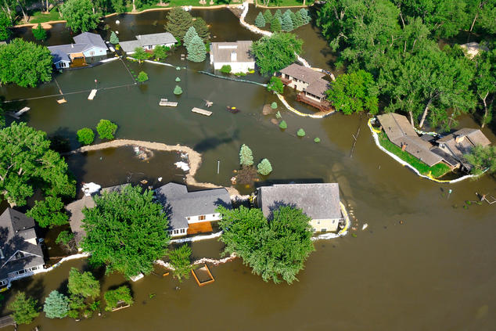The Missouri River encroaches on homes in Sioux City, Iowa, during a 2011 floodStocktrek Images/Media Bakery
Eight degrees Fahrenheit. It may not sound like much—perhaps the difference between wearing a sweater and not wearing one on an early-spring day. But for the world in which we live, which climate experts project will be at least eight degrees warmer by 2100 should global emissions continue on their current path, this small rise will have grave consequences, ones that are already becoming apparent, for every ecosystem and living thing—including us.
According to the National Climate Assessment, human influences are the number one cause of global warming, especially the carbon pollution we cause by burning fossil fuels and the pollution-capturing we prevent by destroying forests. The carbon dioxide, methane, soot, and other pollutants we release into the atmosphere act like a blanket, trapping the sun's heat and causing the planet to warm. Evidence shows that 2000 to 2009 was hotter than any other decade in at least the past 1,300 years. This warming is altering the earth's climate system, including its land, atmosphere, oceans, and ice, in far-reaching ways.

More frequent and severe weather
Higher temperatures are worsening many types of disasters, including storms, heat waves, floods, and droughts. A warmer climate creates an atmosphere that can collect, retain, and drop more water, changing weather patterns in such a way that wet areas become wetter and dry areas drier. "Extreme weather events are costing more and more," says Aliya Haq, deputy director of NRDC's Clean Power Plan initiative. "The number of billion-dollar weather disasters is expected to rise."
According to the National Oceanic and Atmospheric Administration, in 2015 there were 10 weather and climate disaster events in the United States—including severe storms, floods, drought, and wildfires—that caused at least $1 billion in losses. For context, each year from 1980 to 2015 averaged $5.2 billion in disasters (adjusted for inflation). If you zero in on the years between 2011 and 2015, you see an annual average cost of $10.8 billion.
The increasing number of droughts, intense storms, and floods we're seeing as our warming atmosphere holds—and then dumps—more moisture poses risks to public health and safety, too. Prolonged dry spells mean more than just scorched lawns. Drought conditions jeopardize access to clean drinking water, fuel out-of-control wildfires, and result in dust storms, extreme heat events, and flash flooding in the States. Elsewhere around the world, lack of water is a leading cause of death and serious disease. At the opposite end of the spectrum, heavier rains cause streams, rivers, and lakes to overflow, which damages life and property, contaminates drinking water, creates hazardous-material spills, and promotes mold infestation and unhealthy air. A warmer, wetter world is also a boon for food-borne and waterborne illnesses and disease-carrying insects such as mosquitoes, fleas, and ticks.

Higher death rates
Today's scientists point to climate change as "the biggest global health threat of the 21st century." It's a threat that impacts all of us—especially children, the elderly, low-income communities, and minorities—and in a variety of direct and indirect ways. As temperatures spike, so does the incidence of illness, emergency room visits, and death.
"There are more hot days in places where people aren't used to it," Haq says. "They don't have air-conditioning or can't afford it. One or two days isn't a big deal. But four days straight where temperatures don't go down, even at night, leads to severe health consequences." In the United States, hundreds of heat-related deaths occur each year due to direct impacts and the indirect effects of heat-exacerbated, life-threatening illnesses, such as heat exhaustion, heatstroke, and cardiovascular and kidney diseases. Indeed, extreme heat kills more Americans each year, on average, than hurricanes, tornadoes, floods, and lightning combined.

Dirtier air
Rising temperatures also worsen air pollution by increasing ground level ozone, which is created when pollution from cars, factories, and other sources react to sunlight and heat. Ground-level ozone is the main component of smog, and the hotter things get, the more of it we have. Dirtier air is linked to higher hospital admission rates and higher death rates for asthmatics. It worsens the health of people suffering from cardiac or pulmonary disease. And warmer temperatures also significantly increase airborne pollen, which is bad news for those who suffer from hay fever and other allergies.

Higher wildlife extinction rates
As humans, we face a host of challenges, but we're certainly not the only ones catching heat. As land and sea undergo rapid changes, the animals that inhabit them are doomed to disappear if they don't adapt quickly enough. Some will make it, and some won't. According to the Intergovernmental Panel on Climate Change's 2014 assessment, many land, freshwater, and ocean species are shifting their geographic ranges to cooler climes or higher altitudes, in an attempt to escape warming. They're changing seasonal behaviors and traditional migration patterns, too. And yet many still face "increased extinction risk due to climate change." Indeed, a 2015 study showed that vertebrate species—animals with backbones, like fish, birds, mammals, amphibians, and reptiles—are disappearing 114 times faster than they should be, a phenomenon that has been linked to climate change, pollution, and deforestation.

More acidic oceans
The earth's marine ecosystems are under pressure as a result of climate change. Oceans are becoming more acidic, due in large part to their absorption of some of our excess emissions. As this acidification accelerates, it poses a serious threat to underwater life, particularly creatures with calcium carbonate shells or skeletons, including mollusks, crabs, and corals. This can have a huge impact on shellfisheries. Indeed, as of 2015, acidification is believed to have cost the Pacific Northwest oyster industry nearly $110 million. Coastal communities in 15 states that depend on the $1 billion nationwide annual harvest of oysters, clams, and other shelled mollusks face similar long-term economic risks.

Higher sea levels
The polar regions are particularly vulnerable to a warming atmosphere. Average temperatures in the Arctic are rising twice as fast as they are elsewhere on earth, and the world's ice sheets are melting fast. This not only has grave consequences for the region's people, wildlife, and plants; its most serious impact may be on rising sea levels. By 2100, it's estimated our oceans will be one to four feet higher, threatening coastal systems and low-lying areas, including entire island nations and the world's largest cities, including New York, Los Angeles, and Miami as well as Mumbai, Sydney, and Rio de Janeiro.
There's no question: Climate change promises a frightening future, and it's too late to turn back the clock. We've already taken care of that by pumping a century's worth of pollution into the air nearly unchecked. "Even if we stopped all carbon dioxide emissions tomorrow, we'd still see some effects," Haq says. That, of course, is the bad news. But there's also good news. By aggressively reducing our global emissions now, "we can avoid a lot of the severe consequences that climate change would otherwise bring," says Haq.

